Count identifiers in a C program:

Aim:
To write a C program to count the number of identifiers present in a C source program, ignoring keywords, constants, spaces, and special symbols.

Algorithm:
- Start the program.
- Declare an array of C keywords and initialize the identifier count to zero.
- Read the C source code line by line until END is entered.
- Scan each line and identify words beginning with a letter or underscore.
- Check whether each word is a keyword.
- If it is not a keyword, display it as an identifier and increment the count.
- Display the total number of identifiers.
- Stop the program.

Pseudocode:
BEGIN
Initialize keyword list
Set count = 0

READ C source code until END

FOR each line
Scan each character

IF character is a letter or underscore THEN
Extract the complete word

IF word is not a keyword THEN
DISPLAY word
count = count + 1
END IF
END IF
END FOR

DISPLAY total identifier count
END
Code:
#include <stdio.h>
#include <string.h>
#include <ctype.h>
char *keywords[] = {
"int", "char", "float", "double", "void",
"if", "else", "for", "while", "do",
"return", "switch", "case", "break",
"continue", "default", "long", "short",
"signed", "unsigned", "const", "static",
"struct", "union", "enum", "sizeof",
"typedef", "extern", "auto", "register",
"volatile", "goto"
};
int isKeyword(char *word)
{
int i;
for (i = 0; i < sizeof(keywords) / sizeof(keywords[0]); i++)
if (strcmp(word, keywords[i]) == 0)
return 1;
return 0;
}
int main()
{
char line[1000], word[100];
int i, j, count = 0;
printf("Enter C source code (enter END to finish):\n");

while (fgets(line, sizeof(line), stdin))
{
if (strncmp(line, "END", 3) == 0)
break;

i = 0;

while (line[i] != '\0')
{
if (isalpha((unsigned char)line[i]) || line[i] == '_')
{
j = 0;

while (isalnum((unsigned char)line[i]) || line[i] == '_')
{
if (j < 99)
word[j++] = line[i];
i++;
}

word[j] = '\0';

if (!isKeyword(word))
{
printf("%s\n", word);
count++;
}
}
else
i++;
}
}

printf("Total identifiers = %d\n", count);

return 0;
}

Output:
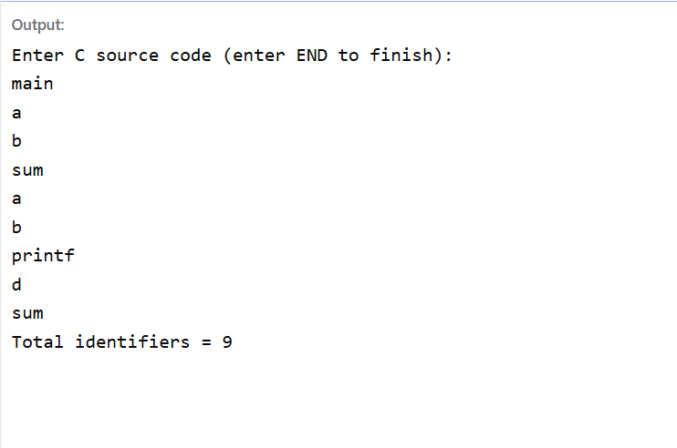

Result:
The C program successfully performs lexical analysis by identifying and classifying tokens such as keywords, identifiers, constants, operators, and special symbols.

